Warning – Reverse Brake Assist – CGEA 1.3

Functional Description

Reverse Brake Assist (RBA) is a driver assistance feature that utilizes sensing modalities looking behind the vehicle to detect obstacles in the vehicle’s path of travel. If a collision with an obstacle is deemed imminent and the driver has not yet intervened, the feature will request automatic braking. Once automatic braking is confirmed, the RBA feature is responsible for notifying the customer that the braking has occurred through vehicle HMI. The RBA Post Event Notification is used to inform the driver of a confirmed Reverse Brake Assist automatic braking event by providing context information via the message center after an RBA braking event occurs. The message center is also used to inform the driver in cases where the Reverse Brake Assist feature becomes unavailable, faulted, or is off.

The Reverse Brake Assist Warning feature correlates the RbaMsg_D_Rq and RbaAlrt_D_Dsply CAN signals, the configuration information, and the operational mode to display the appropriate warning display in the message center.

Interfaces

Interface Context Diagram (I/O Block Diagram)
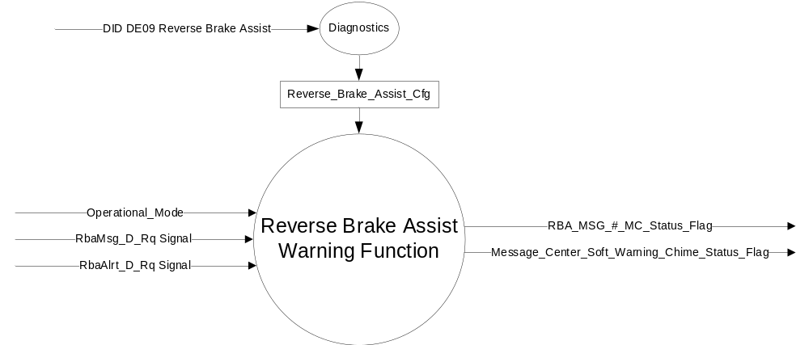

Figure 1 Warning – Reverse Brake Assist Warning Function Context Diagram

Inputs

      - INTERNAL:
            - Operational_Mode
            - Reverse_Brake_Assist_Cfg

- MUX message from the CAN bus

- RbaMsg_D_Rq Signal
Signal Name | Size (bits) | Detail | Units | Res. | Offset | State  Encoded | Min | Max
RbaMsg_D_Rq | 2 |  | SED | 1 | 0 |  | 0 (0x0) | 3 (0x3)
 |  | Null |  |  |  | 0x0
 |  | Off |  |  |  | 0x1
 |  | Unavailable |  |  |  | 0x2
 |  | Fault |  |  |  | 0x3

- RbaAlrt_D_Dsply Signal
Signal Name | Size (bits) | Detail | Units | Res. | Offset | State  Encoded | Min | Max
RbaAlrt_D_Dsply | 2 |  | SED | 1 | 0 |  | 0 (0x0) | 3 (0x3)
 |  | Off |  |  |  | 0x0
 |  | Graphic |  |  |  | 0x1
 |  | Text |  |  |  | 0x2
 |  | Both |  |  |  | 0x3

Outputs
- RBA_MSG_#_MC_Status_Flag that is used to control the Warning displayed in the message center.
- Message_Center_Soft_Warning_Chime_Status_Flag that is used to control the Warning Chime.

Function/Performance

Operational Modes

Mode | Differentiating Vehicle Conditions
Sleep Mode | Inactive
Limited Mode | Inactive
Normal Mode | Reverse Brake Assist Warning Active/Inactive
Crank Mode | Reverse Brake Assist Warning Active/Inactive

Voltage Levels

Refer to the Cluster Features Table located in the Operational Modes and Voltage Range Strategies Section of this SPSS.

Human-Machine Interface

Visual

Indicator Graphics / Display Format
Message Center Text Warning Message as defined in section 1.3.5.1 of this document.

1.3.3.1.2 Indicator Color Coordinates

Reference section COLOR & ILLUMINATION REQUIREMENTS (GRAPHICS)

1.3.3.1.3 Indicator Characteristics

Refer to Message Center X Display_Y Button Interface Section, where X and Y are appropriate values in this document.

Audio

Message_Center_Soft_Warning_Chime_Status_Flag as defined in section 1.3.5.1 of this document.

Switch Control Logic

None.

System Accuracy

The state of the message center flags shall change within 100 msec of a state change as indicated in the state matrix found in section 1.3.5.1 of this document.

Operation: Performance and Functional

Subsystem Algorithm Flowchart / State Diagram

- RBA_MSG_#_MC_Status_Flags based on RbaMsg_D_Rq
Operational  Mode | Reverse_Brake_  Assist_Cfg | RbaMsg_D_Rq | RBA_MSG_1_  MC_Status_Flag | RBA_MSG_2_  MC_Status_Flag | RBA_MSG_3_  MC_Status_Flag
Normal or Crank | 0x1 (Enabled) | Null (0x0) | Inactive | Inactive | Inactive
Normal or Crank | 0x1 (Enabled) | Off (0x1) | Active | Inactive | Inactive
Normal or Crank | 0x1 (Enabled) | Unavailable (0x2) | Inactive | Active | Inactive
Normal or Crank | 0x1 (Enabled) | Fault (0x3) | Inactive | Inactive | Active
Normal or Crank | 0x1 (Enabled) | Missing | Inactive | Inactive | Inactive
All other cases |  |  | Inactive | Inactive | Inactive

- RBA_MSG_#_MC_Status_Flags based on RbaAlrt_D_Dsply
Operational  Mode | Reverse_Brake_  Assist_Cfg | RbaAlrt_D_Dsply | RBA_MSG_4_  MC_Status_Flag
Normal or Crank | 0x1 (Enabled) | Off (0x0) | Inactive
Normal or Crank | 0x1 (Enabled) | Graphic (0x1) | Inactive
Normal or Crank | 0x1 (Enabled) | Text (0x2) | Active
Normal or Crank | 0x1 (Enabled) | Both (0x3) | Active
Normal or Crank | 0x1 (Enabled) | Missing | Inactive
All other cases |  |  | Inactive

- RBA_MSG_#_MC_Status_Flags to MC Warning Message ID and Chime_Status_Flag
RBA_MSG_#_MC_Status_Flag | MC Warning  Message ID | Sample text | Active Chime_Status_Flag
RBA_MSG_1_MC_Status_Flag | W3622 | Reverse Brake Assist  Off | None
RBA_MSG_2_MC_Status_Flag | W3620 | Reverse Brake Assist  Not Available  See Manual | Message_Center_Soft_  Warning_Chime_Status_Flag
RBA_MSG_3_MC_Status_Flag | W3621 | Reverse Brake Assist  Fault | Message_Center_Soft_  Warning_Chime_Status_Flag
RBA_MSG_4_MC_Status_Flag | W3623 | Reverse Brake Assist  ICON | None

Operation Description (supports algorithm flowchart /state diagram)

- Message Center Warning ID W3620 will be Active whenever RBA_MSG_2_MC_Status_Flag is Active.
- Message Center Warning ID W3621 will be Active whenever RBA_MSG_3_MC_Status_Flag is Active.
- Message Center Warning ID W3622 will be Active whenever RBA_MSG_1_MC_Status_Flag is Active.
- Message Center Warning ID W3623 will be Active whenever RBA_MSG_4_MC_Status_Flag is Active.

Function Safety Classification (EMC)

Class B

Memory Storage

Parameter Name | Description | Value at  Battery Connect | Value at  Module  Wake-up
RBA_MSG_#_MC_Status_Flag | Used to control the state of the warning to the Message Center arbitrator | Inactive (0X0) | Inactive (0X0)
RbaMsg_D_Rq | CAN signal | 0x0 | 0x0
RbaAlrt_D_Dsply | CAN signal | 0x0 | 0x0
Message_Center_Soft_Warning_Chime_Status_Flag | Used to control the state of the warning chime to the Chime arbitrator | Inactive (0X0) | Inactive (0X0)
Operational_Mode | 4 state indicator for cluster operational mode | Limited | Limited or Normal or Crank

Prove Out

No.

Reconfigurable Telltale

No.

Message Center Msg

Refer to Text: Program Master Warning Message List.xls | Program Translation Table.xls warning
W3620, W3621, W3622, and W3623.

Error Handling

Missing Message/Undefined Data Strategy

The signals will be declared missing as per the Diagnostics section of this SPSS.

DTCs states and history will be determined as per the Diagnostics section of this SPSS.

If Reverse_Brake_Assist_Cfg is Disabled, DTC's shall never be logged for this feature.

Invalid Message Strategy

None.

Diagnostics

Self Test

None

Engineering Test Mode

Reference section “Dealer / Engineering Test Mode (ETM)”

Part II Performance

Supported Diagnostic DIDs (Service $22 and $2F)

Supported Diagnostic Trouble Codes (DTCs)
DTC | Description | When Logged
C23B00 | Lost Communication With Image Processing Module B | Message missing for at  least 5 consecutive seconds.

DID DExx Configuration
Block  Num | Block Description | Byte(s) | Bits | State: Description | "0" | "1" | Default | Comments/Information
PACKETED BLOCKS
$xx | Option Content (B&A) | * | * | Reverse Brake Assist | Disabled | Enabled | Disabled | Disabled means the Reverse Brake Assist feature is not present in the vehicle and RBA warnings will not be displayed. Enabled means the Reverse Brake Assist feature is present in the vehicle and RBA warnings can be displayed in the IPC.
*Byte and bit location to be identified in Part II Specification for this cluster

Reference Specification

IS-0001 WARNINGS/INDICATORS/DISPLAYS PROVEOUT
IS-0052 OPERATING VOLTAGES - FUNCTIONAL/PERFORMANCE
IS-0069 FUNCTIONAL IMPORTANCE CLASS
IS-0324 WINDSHIELD & OTHER REFLECTIONS
IS-0327 WARNING INDICATOR EVALUATION
IS-0379 NORTH AMERICAN WARNINGS AND INDICATORS STRATEGY

IL-0017 TELLTALE AND INTERIOR ILLUMINATION – COLOR AND INTENSITY
IL-0019 GENERAL ILLUMINATION DIMMING
IL-0021 CRAFTSMANSHIP – DISPLAYS
IL-0022 GENERAL ILLUMINTATION COLOR
IL-0023 CLARITY/LEGIBILITY/READABILITY/VISUAL CONTRAST
IL -0043 OPERATIONAL ENVIRONMENT FUNCTIONALITY
IL -0045 COLOR
IL -0047 TELLTALE, INDICATOR AND DISPLAY LIGHT INTENSITY
IL -0048 ILLUMINATION ACCEPTABILITY

03-0661 PLACEMENT: CONTROL AND DISPLAY LOCATIONS
03-0662 PLACEMENT: LOGICAL GROUPING FUNCTION AND USAGE
03-0664 PLACEMENT: DOWN VISION TO COMPONENTS WITH HIGH VISUAL DEMAND
03-0665 PLACEMENT: EXPECTED LOCATIONS OF CONTROLS AND DISPLAYS VDS
03-0670 INTERIOR VISIBILITY
03-0671 INTERIOR VISIBILITY: REFLECTIONS FROM COMPONENTS & SURFACES
03-0672 INTERIOR VISIBILITY: REFLECTIONS IN DISPLAYS
03-0673 INTERIOR VISIBILITY: VISUAL OBSCURATIONS
03-0674 INTERIOR VISIBILITY: ILLUMINATION CONTROLS / DISPLAYS
03-0675 INTERIOR VISIBILITY: VEILING GLARE
03-0677 INTERIOR VISIBILITY: SUNLIGHT WASHOUT
03-0681 IDENTIFICATION: CHARACTER AND SYMBOL SIZE
03-0682 IDENTIFICATION: LEGIBILITY
03-0685 IDENTIFICATION: SYMBOLS, ABBREV FOR CONTROL
03-0721 LOGIC OF OPERATION: OPERATIONAL STEREOTYPES
03-0722 LOGIC OF OPERATION: INTERPRETATION
03-0723 LOGIC OF OPERATION: USE OF SYSTEMS WITH VISUAL DISPLAYS

Revision History

SPSS Module Revision History

Revision Level | Name | Change Description | Date
1.0 | J. Gregoire | Initial Release. Robert Klosek (rklosek) is the feature owner. | 02/20/2017
1.1 | J. Gregoire | Changes highlighted in Yellow.  Peer review: Scott Watkins  Clarification  Supplier Q&A (Denso 1247809) – In section 1.2 interfaces Reverse Brake Assist cfg is in input, but Table 1.2 and Table 1.3 are missing Reverse Brake Assist cfg. Denso's understanding is that Reverse Brake Assist cfg should be enabled to trigger the warning.  Page 3 Table 1.2 – Add Reverse_Brake_Assist_Cfg.  Page 3 Table 1.3 – Add Reverse_Brake_Assist_Cfg. | 06/13/2018

